Tracking the Macroinvertebrate (Bug) Data in the Upper Missouri River collected by UMOWA from 2015-2024
By David Stagliano, Aquatic Ecologist, Montana Biological Survey
It doesn’t take a scientist to know that there have been a lot of changes going on in the Missouri River over the last decade or more. Record high flows in 2018 and a smaller flushing flow in June 2023 can have dramatic effects on the “insects” that you see hatching or not hatching from the river sections each year. The summer drought of 2021 marked one of the first times the Wolf Creek to Craig section was placed under “hoot owl” restrictions. Flushing flows can clean silt out of gravel habitats preferred by mayflies and caddisflies and affect larval populations that produce adults the following year. This past year, as we have since 2015 (except in 2020), UMOWA collected macroinvertebrate samples at seven sites from Wolf Creek to Cascade, since 2021, we have focused on sampling in Fall. Prior to this, we collected samples in Spring, Summer and Fall. This data on the invertebrate populations, as well as water quality (WQ) collected by UMOWA can now be represented visually. UMOWA’s River Health dashboard https://umowa.shinyapps.io/dashboard/ now has that data presented in a user-friendly fashion with different years and insect metrics presented in graphs of the users’ interests. You can choose from Aquatic Insects, Water Quality, Discharge and Temperature or Trout.
Once you click on the Aquatic Insect Tab, you can easily toggle across years or sites or different insect metrics with the click of a mouse, no more digging through reports for this information. Do you want to know what year or site has had the best tan caddisfly hatches in the past decade check this out, or for future projections-- based on the Fall 2024 samples, it looks like during summer of 2025, there should be some abundant tan caddisflies hatching downstream of the Dearborn River (see graph below).
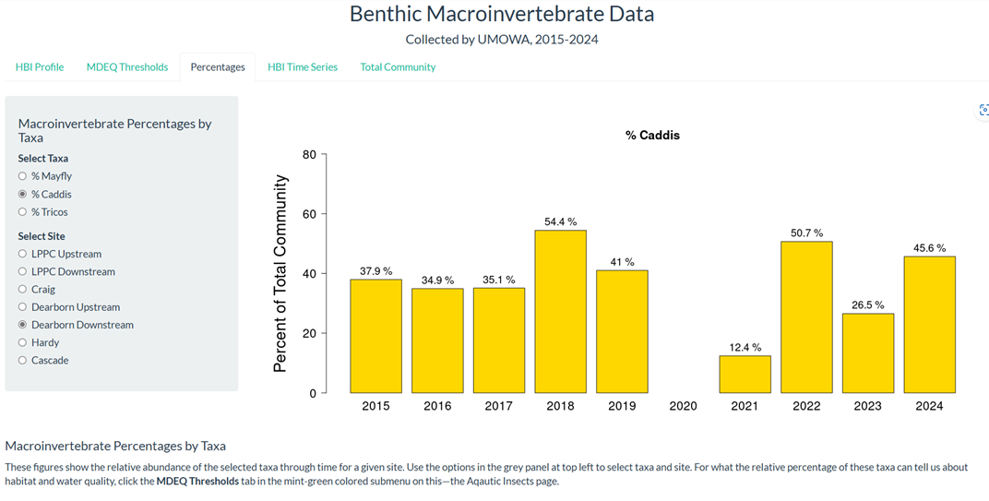
In the graphs below, you can also see how larger river flows out of Holter Dam affect the overall health of the macroinvertebrate community (2018 vs. 2024). HBI scores measure the tolerance of the bug community to sediment; the more bugs that tolerate silt the higher the score, but the worse the health of the river site. During the high flows of 2018, none of the monitoring sites scored in the poor range (Left Figure below), but in 2024, without flushing spring flows, 2 sites near Wolf Creek and Craig scored in the poor range (Right Figure below)
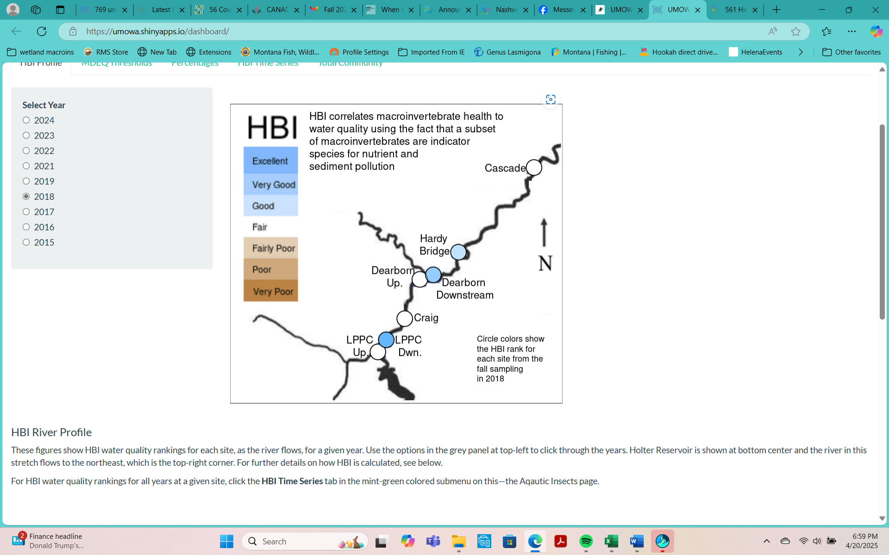
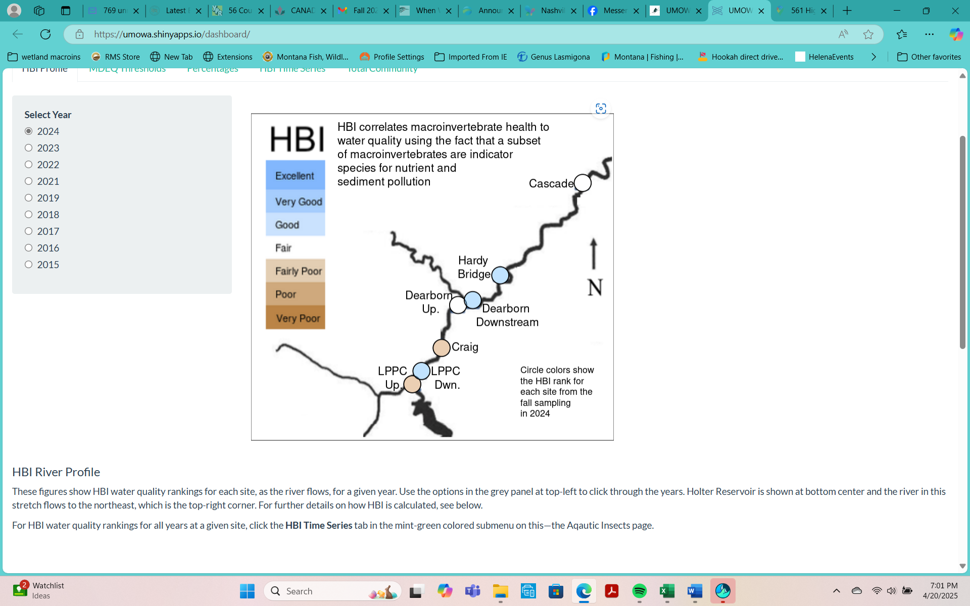
Figure 1. HBI score qualitative health rankings for 2018 (left) and 2024 (right).
You can find this type of data and more information on UMOWA’s River Dashboard River Data - Upper Missouri Watershed Alliance

